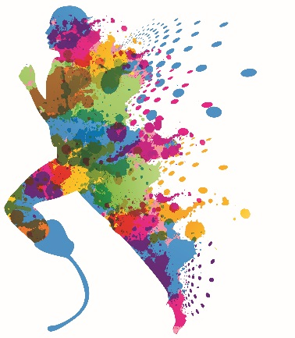

|  |  |
| --- | --- |
|  |  |
| Abeilles | Appeal |
|  |  |
| Bambi | Bang Couleur |

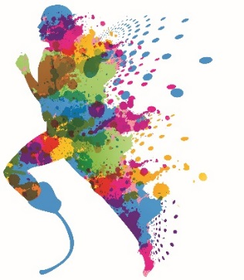



|  |  |
| --- | --- |
|  |  |
| Bang Noir | Blanc |
|  |  |
| Camouf | Camouf |





|  |  |
| --- | --- |
|  |  |
| Carbone 1 | Carbone 2 |
|  |  |
| Carre Noir | Chair |





|  |  |
| --- | --- |
|  |  |
| Clown | Ecossais |
|  |  |
| Fashion | Fillette |





|  |  |
| --- | --- |
|  |  |
| Froissé Bleu | Fun Flying |
|  |  |
| Galet | Heart N Roses |





|  |  |
| --- | --- |
|  |  |
| Jainero | Jeans |
|  |  |
| Jeans Fluo | Jim Jaune |





|  |  |
| --- | --- |
|  |  |
| Jim Marron | Noir |
|  |  |
| Ours Blanc | Ours Marins |





|  |  |
| --- | --- |
|  |  |
| Viciou Sasmira | Vroum |

